**Appendix S2. Supplemental Results and Figures**



**Figure S1**. Species richness for each sampling period from initial planting, based on initial (a) phylogenetic diversity treatment (**L**ow, **M**edium, **H**igh) or (b) functional diversity treatment (**L**ow, **H**igh). Means with the same letter were not significantly different based on one-way ANOVA followed by post-hoc Tukey’s test.

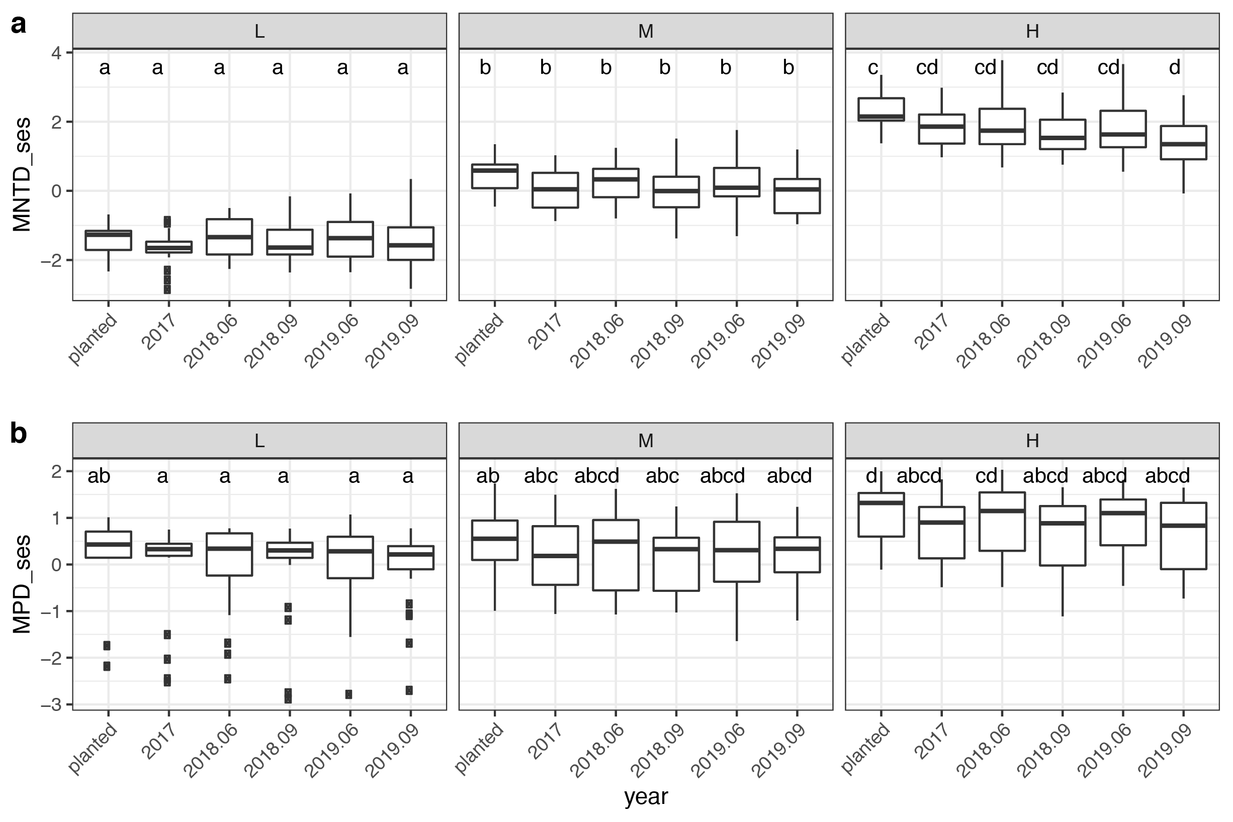

**Figure S2.** Phylogenetic diversity as measured by the standardized effect size of mean nearest taxon distance (MNTDses) and mean pairwise distance (MPDses), for each sampling period from initial planting, based on initial phylogenetic diversity class (**L**ow, **M**edium, **H**igh).



**Figure S3.** Non-metric dimensional scaling ordinations based on plots phylogenetic dissimilarity.(a) Mean nearest taxon distance (MNTD), and (b) mean pairwise distance (MPD) by plot’s phylogenetic diversity class as designed (**L**ow, **M**edium, **H**igh) from starting position (as planted) to final year surveys (2019.06 and 2019.08). This pattern of compositional divergence is strongest based on measures of MPD (b), which might be explained by the sensitivity of MPD to phylogenies with deep branching. This would suggest turnover bias of species with greater phylogenetic distinctiveness (long independent branches are preferentially lost) in low PD plots; however, we found no significant differences in phylogenetic distinctiveness measures given permutations of the same number of randomly dropped tips (L: *p=*0.36, M: *p=*0.36; H: *p=*0.35).



**Figure S4.** Non-metric dimensional scaling ordinations for presence-absence data for early-season surveys.



**Figure S5.** Non-metric dimensional scaling ordinations given vegetative cover data.



**Figure S6.** Species in trait space with the top ten simper species labeled. Color represents mean change in vegetative cover from year 1 (2017) to final survey (2019). Size represents the average simper contribution to the dissimilarity.

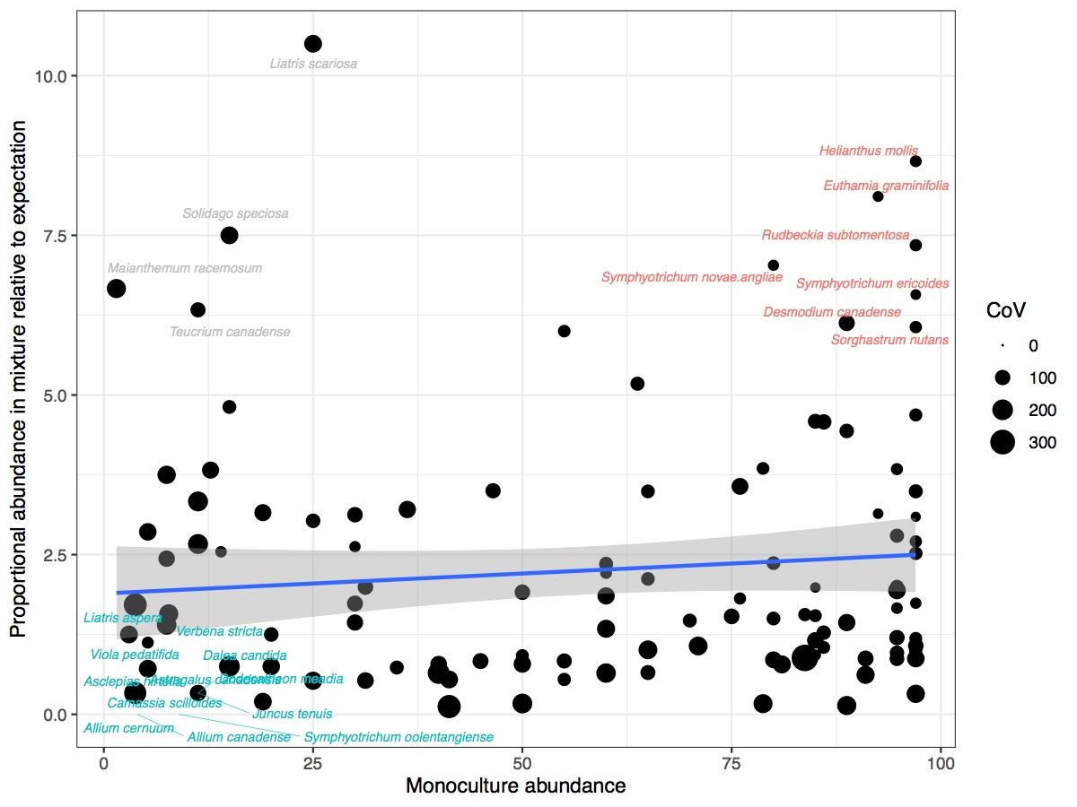

**Figure S7**. Species’ monoculture abundance and the mean proportional abundance in mixture plots relative to the expectation from monocultures. Species point sizes show the coefficient of variation (CV) in mean cover values across all plug plots.



**Figure S8**. Non-metric dimensional scaling ordinations of individual plots in trait space given starting position (2016) and final survey (2019) with functional traits fit to ordination axes. Black arrow indicates the mean shifts in plots.

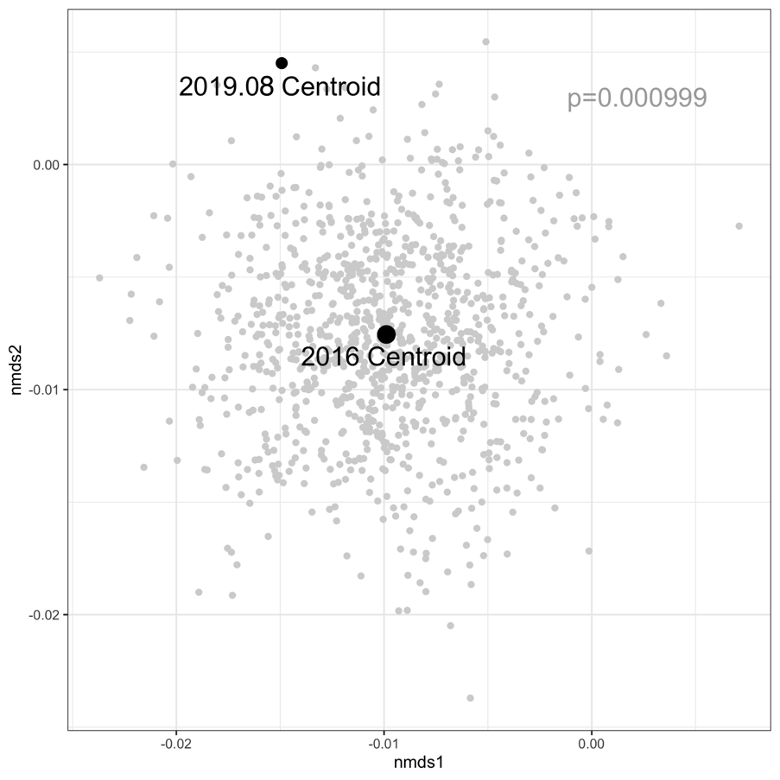

**Figure S9**. Simulated centroids for the expected final survey (2019.08) given observed starting (2016) and ending plot positions in functional trait ordination space.